____ Headphones (no earbuds) for classroom use

____ 1 hard **plastic pencil** box

____ 24 pencils (sharpened)

____ 2 spiral notebooks (**wide ruled no decorations**)

____ 4 boxes of 24 count **Crayola** crayons

____ 6 Elmer's glue sticks

____ 1 binder (1 inch white with clear view front)

____ 1 pair of child's Fiskars blunt tipped scissors

**BOYS**

____ 1 container of Clorox wipe ____ 1 box of gallon bags

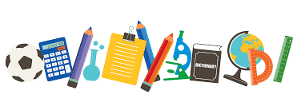

____ 1 box of tissues

____ 1 composition notebook

____ 2 bottles of antibacterial hand soap

____ 1 pack of **BLACK** Expo dry erase

markers (chisel point)

____ 1 pack of **BLACK** Expo dry erase

markers (fine point)

**GIRLS**

____ 1 ream of copy paper

____ 1 bottle of hand sanitizer